**Organic shop**

An organic shop typically refers to a retail establishment that specializes in selling organic products. These products are sourced from organic farming methods, which emphasize sustainable practices, natural fertilizers, and avoiding synthetic chemicals, pesticides, and genetically modified organisms (GMO)

**Requirements**

**Landing page(Home):**

-As shown in given image in landing page there must be tag line of your store and images must be scrollable

-Just below of it you have to display your services as show in image

-just below of it you have to display your best selling product with images

-just below to it display any special offer

-just below of it display customer review with photo in scrolling format

-just below of it show your more brands

-At last create footer for web app and devide it into three part as shown in image and display information

**About Section**

The "About Us" page of an organic store typically provides visitors with information about the store's background, mission, values, and commitment to organic principles. Here's a breakdown of the information you might find on an "About Us" page for an organic store:

In About part you can display or view

**-Store Background**: This section may include details about when the store was established, its founders, and the inspiration behind starting the organic store.

**-Mission Statement**: The mission statement outlines the core purpose and objectives of the organic store.

**-Values and Philosophy**: This section articulates the values and principles that guide the operations and decision-making processes of the organic store.

**-Commitment to Organic Standards**: The "About Us" page often emphasizes the store's dedication to upholding organic standards and certifications.

-**Local Community Involvement**: Some organic stores are deeply rooted in their local communities and actively participate in community initiatives, events, and partnerships.

-**Team or Staff**: Introducing the team or staff members behind the organic store adds a personal touch and helps customers connect with the people behind the business.

-**Sustainability Practices**: Many organic stores prioritize sustainability in their operations, such as reducing waste, conserving energy, or implementing eco-friendly packaging solutions.

-**Customer Service Commitment**: Organic stores often emphasize their dedication to providing excellent customer service and fostering positive relationships with customers.

**Testimonials or Reviews**: Including customer testimonials or reviews can help build trust and credibility with potential customers. Sharing positive experiences from satisfied customers reinforces the store's reputation for quality products and service.

**Contact Information**: The "About Us" page typically includes contact information, such as the store's address, phone number, email address, and links to social media profiles.

-**Google map location:**

**All Products**

Organic shops offer a wide range of organic products, including fresh produce (fruits, vegetables), grains, pulses, dairy products (milk, cheese, yogurt), meat, poultry, eggs, pantry staples (flour, sugar, spices), snacks, beverages, personal care items, cleaning products, and more**.**

**Display product as shown below**

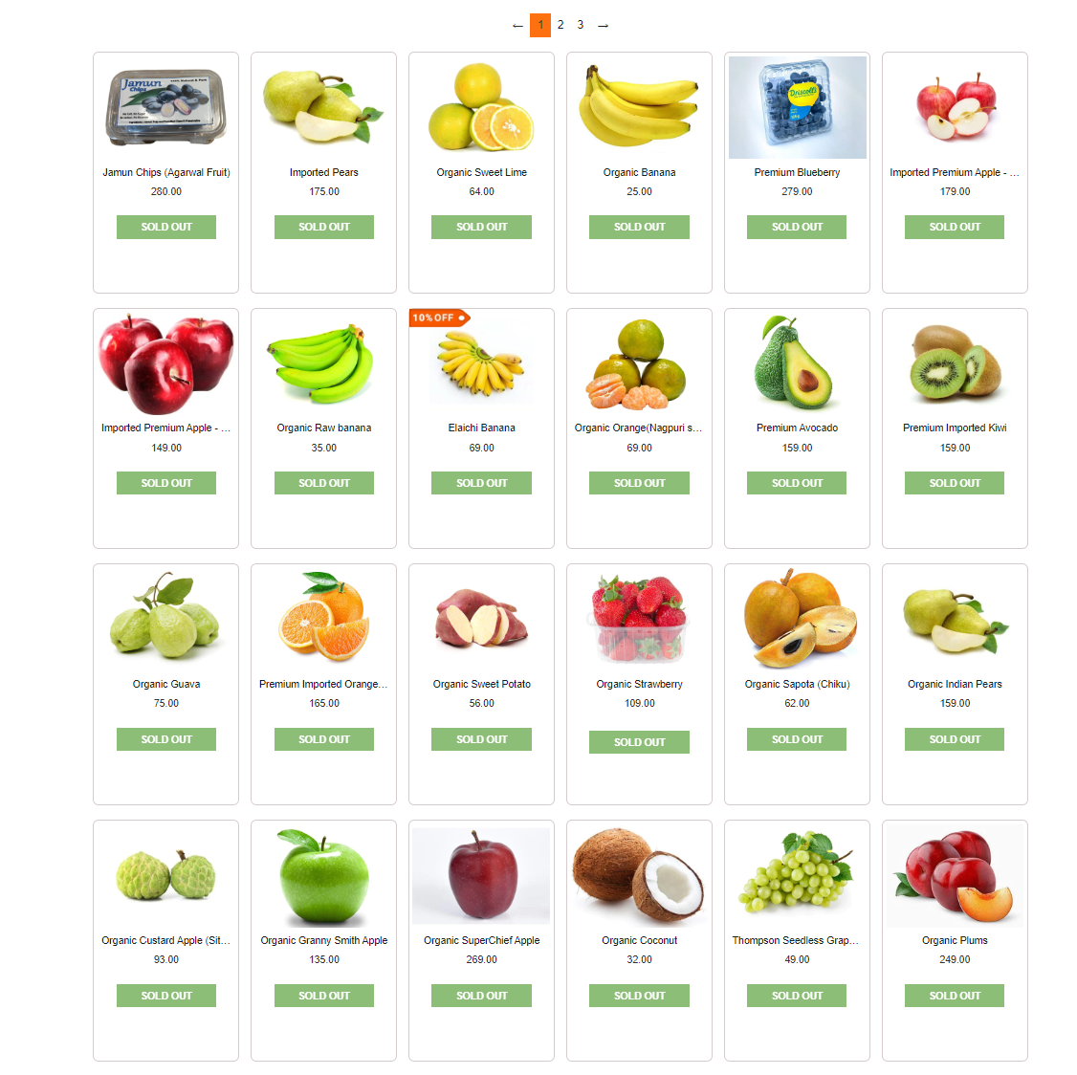

**users must log in before making purchases, you'll need certain requirements to ensure a smooth and secure shopping experience.**

**-** Here's a list of requirements:

**-User Authentication System**: Implement a user authentication system that allows users to register, log in, and manage their accounts securely. This system should include features such as userid, password, email, and more .

- **User Registration**: Provide a user registration form where new users can sign up for an account by providing their email address, username, and password. Optionally, you can include additional fields like name, address, and phone number.

- **Login Page**: Create a login page where registered users can log in using their email address or username and password.

- **Session Management**: Implement session management to keep track of user authentication status throughout their browsing session. This ensures that users remain logged in as they navigate the site and add items to their shopping cart.

- **Shopping Cart**: Develop a shopping cart feature that allows users to add products to their cart while browsing the store. The shopping cart should display the list of items added, their quantities, and the total price. Users should be able to edit the contents of their cart and proceed to checkout.

**the admin plays a crucial role in managing various aspects of the website or application. Here are the key responsibilities of the admin**

**-Product Management**:

* Adding new products to the inventory.
* Updating product descriptions, prices, and images.
* Removing discontinued or out-of-stock products.
* Categorizing products into appropriate categories and subcategories.
* Managing product attributes such as sizes, colors, and variations.

- **Order Management**:

* Monitoring and processing incoming orders.
* Updating order status (e.g., processing, shipped, delivered).
* Handling order cancellations, returns, and refunds.
* Generating invoices and packing slips for orders.
* Communicating with customers regarding order status and inquiries.

- **User Management**:

* Managing user accounts, including creating new accounts, editing profiles, and deleting accounts if necessary.
* Monitoring user activity, such as login attempts and order history.
* Handling user inquiries, feedback, and complaints.
* Implementing and enforcing user policies, such as terms of service and privacy policies.

- **Content Management**:

* Updating website content, including text, images, banners, and promotional materials.
* Managing blog posts, news articles, or other informational content.
* Ensuring that all content complies with legal and regulatory requirements

**To design an Entity-Relationship (ER) diagram for an online organic shop involving users, products, and orders, we need to identify the main entities and their relationships.**

**Entities**:

1. User
2. Product
3. Order

**Relationships**:

1. A user can place zero or more orders.
2. An order must be placed by exactly one user.
3. An order can contain one or more products.
4. A product can be included in zero or more orders.

**Attributes**:

* User:
  + User_ID (Primary Key)
  + Username
  + Email
  + Password
  + Address
  + Phone_Number
* Product:
  + Product_ID (Primary Key)
  + Name
  + Description
  + Price
  + Stock_Quantity
* Order:
  + Order_ID (Primary Key)
  + User_ID (Foreign Key referencing User)
  + Order_Date
  + Total_Amount
* Order_Item:
  + Order_Item_ID (Primary Key)
  + Order_ID (Foreign Key referencing Order)
  + Product_ID (Foreign Key referencing Product)
  + Quantity
  + Subtotal

Here's the ER diagram:

+-----------+ +-------------+ +------------+

| User | | Product | | Order |

+-----------+ +-------------+ +------------+

| User_ID | <-----| Product_ID |------> | Order_ID |

| Username | | Name | | User_ID |

| Email | | Description | | Order_Date |

| Password | | Price | | Total_Amt |

| Address | | Stock_Qty | +------------+

| Phone_Num | +-------------+

+-----------+

|

| 1

|

+--------------+

| Order_Item |

+--------------+

| Order_Item_ID|

| Order_ID |

| Product_ID |

| Quantity |

| Subtotal |

+--------------+

an online organic shop offers a convenient and accessible way for customers to purchase organic products from the comfort of their own homes, while also supporting sustainable agriculture practices and healthy living. It will provide facility like **Product Range, Website Interface, User Registration and Login, Product Selection, Shopping Cart, Checkout Process, Order Fulfillment**